To
The Superintendent of Customs,
Office of Assistant Commissioner of city customs
Postal Appraising department
GPO post office building, ground floor, Bangalore 560001.
Ph: 08022869992 | Email: cuspadlma@gmail.com

Dear Sir,
Sub: Tracking Number RB650660170SG/Local parcel number 47360 regarding.

I have purchased small binocular (SV29) from Aliexpress.com (Tracking Number RB650660170SG). The value of item is USD 47.49 (Equalent to INR 3,466.94 as per the credit card statement). I am obliged to pay the necessary custom duty (if any). Kindly request you to release the parcel.

Your Sincerely

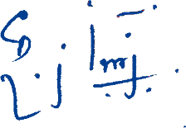
[ Rajkumar Rathinavelu ]
Enclosures:
- Tracking details of parcel
- Invoice for the transaction.
- Payment Proof document (HDFC credit Card Statement)

From
Rajkumar Rathinavelu
ITC Limited
No:3, 1st Main, 1st Phase, Peenya Industrial Area, Bangalore-560058
Ph: 080-41654415; Mobile: +91 9164753973; Email: r@rajkumar.in

