Subabul Clonal Multiplication
Transfer of Technology – 2.0

Executive summary

Lateral shoot cuttings are used for multiplication of Subabul clones, but cuttings vary in thickness and orientation depending on management practice of mother plants. Root system and rooting potential of cuttings vary with environmental conditions like light and temperature, and growth of mother plants. Mother plants maintained in shade produce desirable type of lateral cuttings with high rooting potential and good root distribution, along greater length of stem, than those raised in direct sunlight. Propagation conditions in mist chamber also influence the proportion of rooted cuttings with long root zone (roots spread over more than 2.5 cm length of stem). Application of rooting hormone improves root zone length and number of roots. Psyllid infestation in mother plants affect rooting rate of Subabul cuttings. A combination of best practices of mother plant management, mist propagation system and hormone treatment can produce uniform clonal planting stock with good root system in Leucaena.
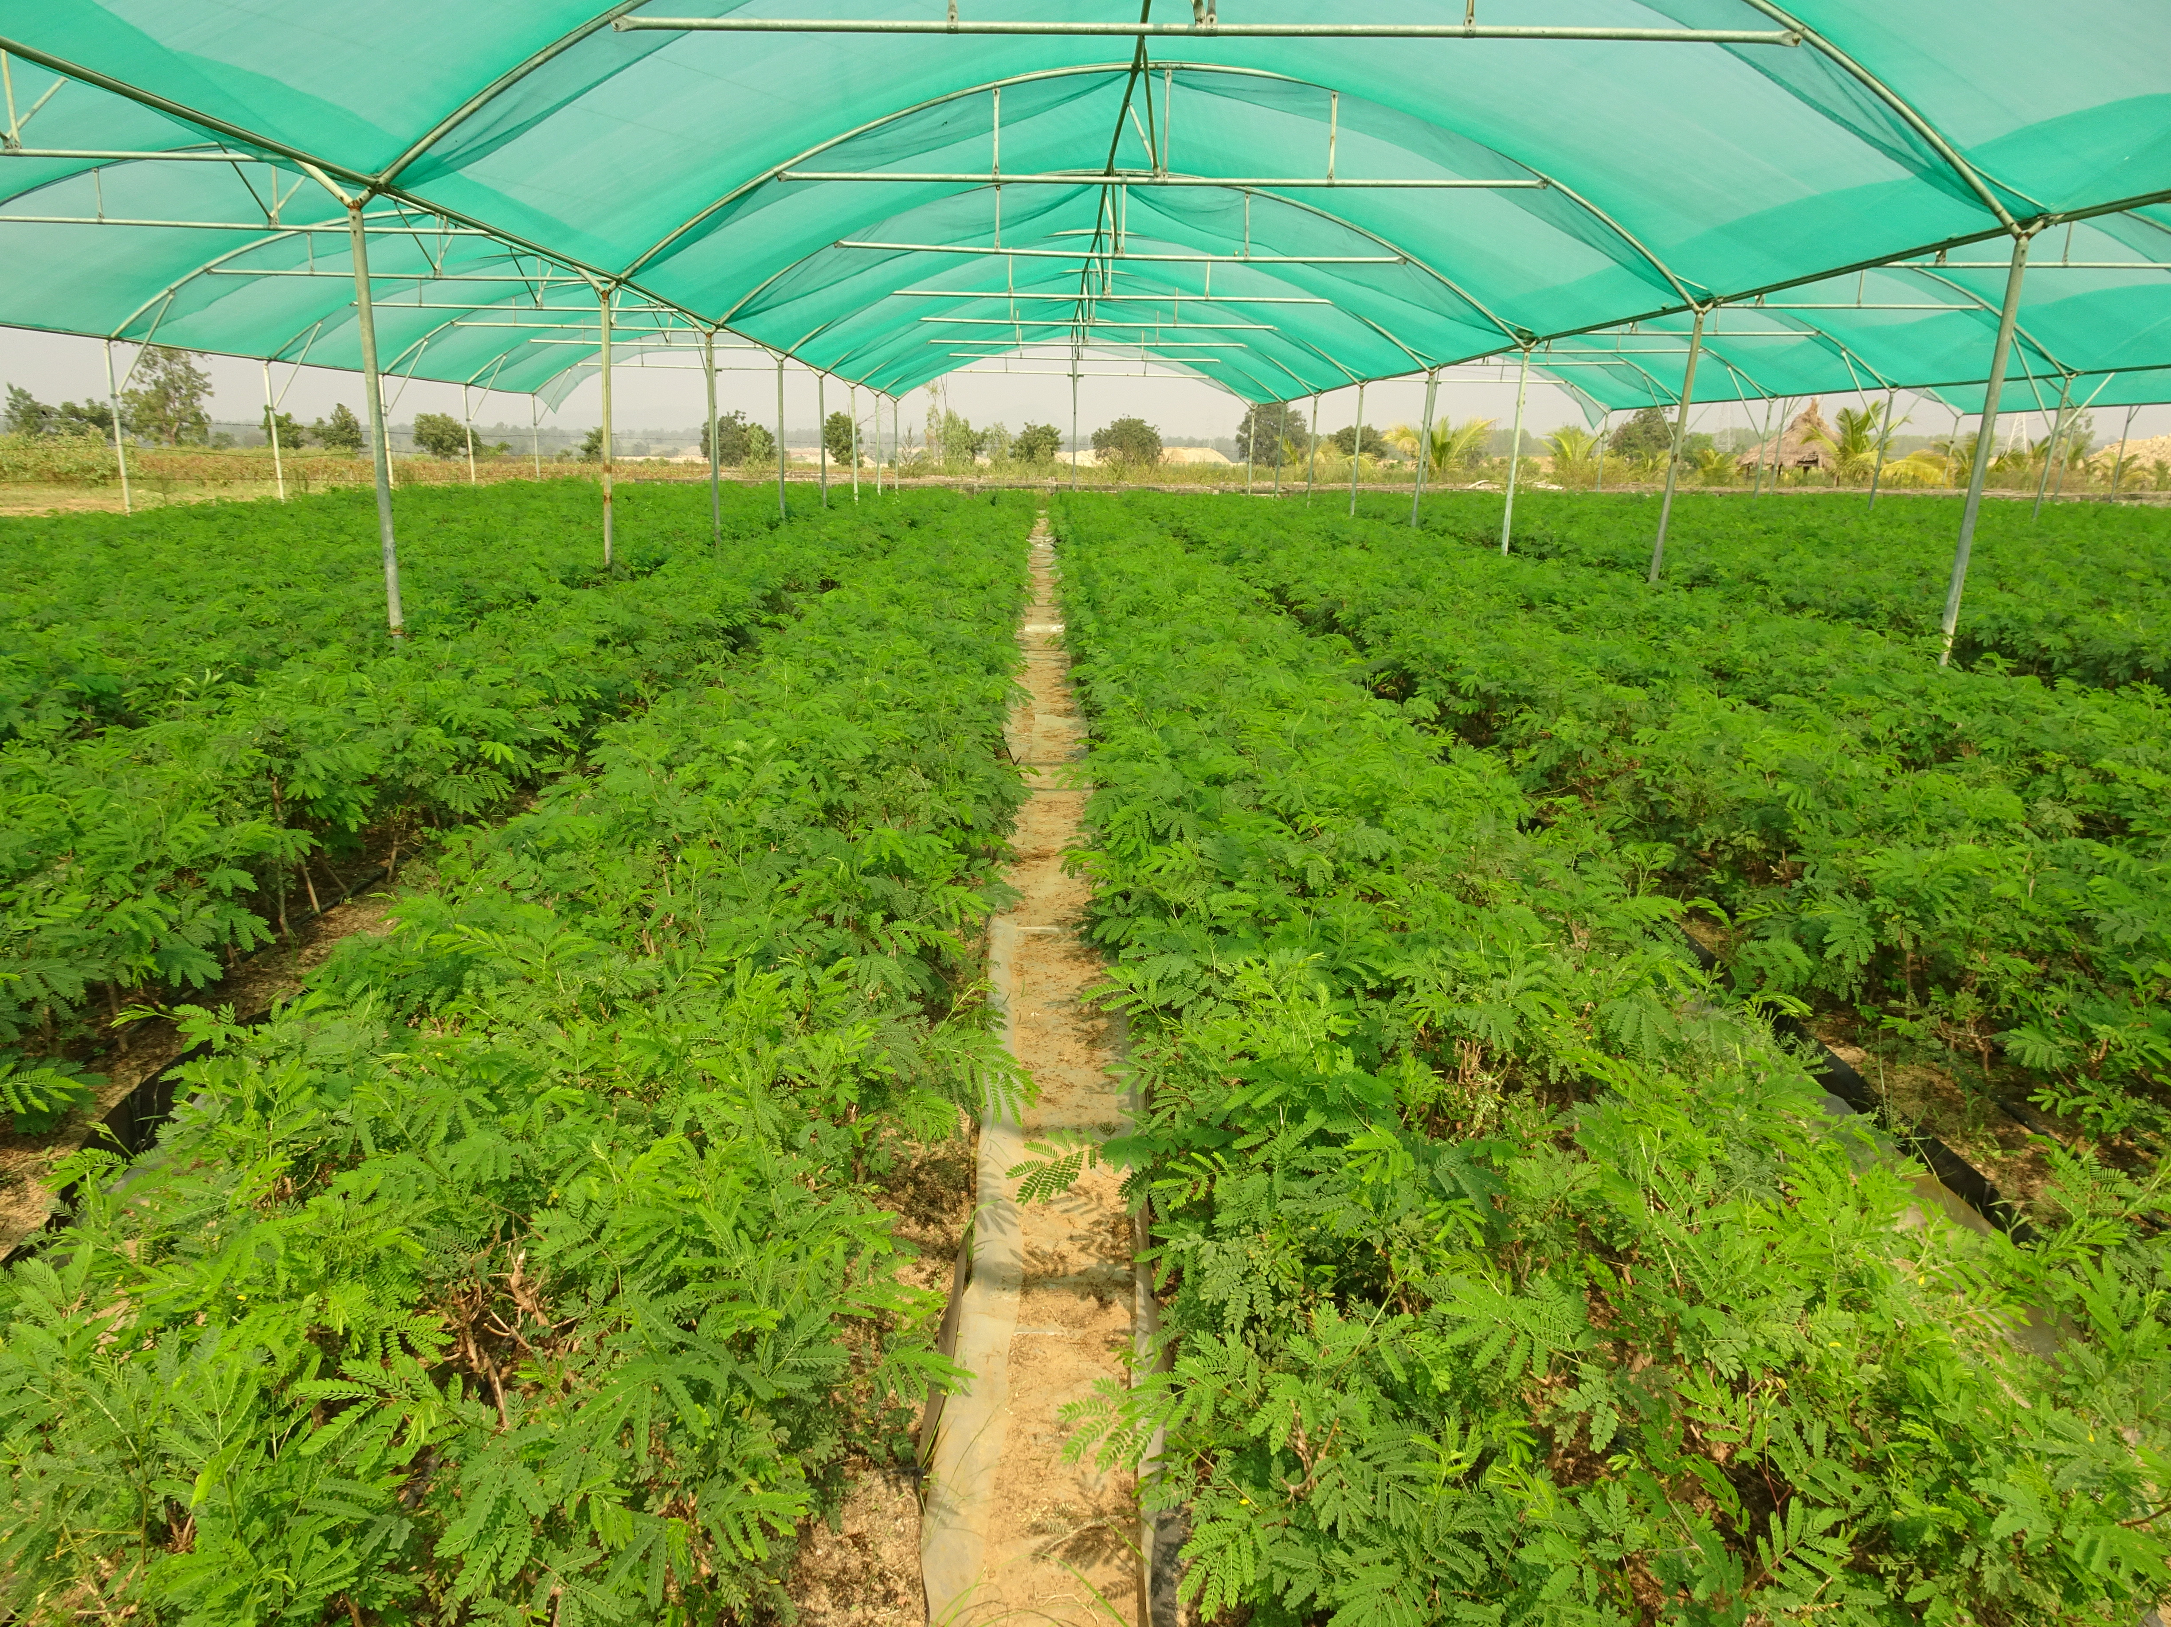
Contents
No | Contents | Page
1 | Introduction | 3
2 | Impact of hormone application on root traits | 4
3 | Effect of mist system on root traits | 4
4 | Impact of type of mother plant and shade on root traits | 8
5 | Impact of insect infestation in mother plants | 9
6 | Standard operating procedure | 12

Introduction

Vegetative propagation of Subabul clones is successfully practised using lateral shoot cuttings of stock mother plants from sand beds, to get more than 80% rooting and balanced root distribution (Scale 5 - Table 1).
Management practice of mother plant plays a crucial role in determining the quality of cuttings, as it influences the root architecture of Subabul propagules. Lateral cuttings produced from mini-cutting production area (MCPA), open sand beds (OMCPA) and field planted mother plants (HDCMA) vary in juvenility and rooting ability, depending on the orientation in the main stem. Environmental conditions influence lignification of cuttings which impact the endogenous hormone levels, and response of cuttings to exogenous hormone application. Temperature and humidity conditions in mist chamber also play a significant role in determining the root system of cuttings. It is observed that there is drastic difference in root system of propagules. Rooted plants can be categorised into different groups based on rooting pattern. Propagules are classified into six groups based on length of root zone (Figure1): Group 1 (0.5-1.5 cm), Group 2 (1.6-2.5 cm), Group 3 (2.6-3.5 cm), Group 4 (3.6-4.5 cm), Group 5 (4.6-5.5 cm) and Group 6 (>5.6 cm).

Table 1. Root distribution pattern in Subabul cuttings
Scale | Class | Root Distribution | No. of roots
1 | Poor rooting | Nil/One side | 0-1
2 | Slight rooting | One Side | 2-4
3 | Moderate rooting | Two Sides | 5-10
4 | Good rooting | 2-3 sides | 11-15
5 | Heavy rooting | All around | >15

Impact of hormone application on root traits

Cuttings treated with IBA (5000 ppm) have better root system than untreated cuttings, though rooting rate is similar. Root pattern is influenced by IBA application. Untreated cuttings have 40% lower root zone length, and 70% plants are of the lower root zone category (Group 1&2 - less than 2.5 cm length) compared to those treated with IBA (Table 2). High rooting rate (above 80%) is achieved in IBA treated cuttings, without much difference in summer and winter seasons. Root distribution and number of roots (21–22) are also at par in cuttings multiplied in both seasons.

Effect of mist system on root traits

Propagation system has a significant impact on rooting rate as observed across two mist chambers, MC 1 (87%) and MC 2 (68%) for the same set of MCPA cuttings (Table 3). Along with reduction in rooting rate, there is drastic difference in rooting pattern also, as 90% cuttings in MC 2 had low root zone length (less than 2.5 cm) whereas 77% cuttings rooted in MC 1 were of Group 3 and above (root zone of more than 2.6 cm length - Figure 2).
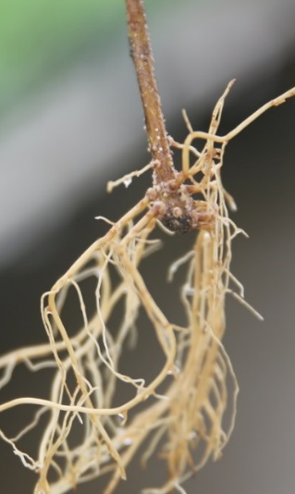  a | 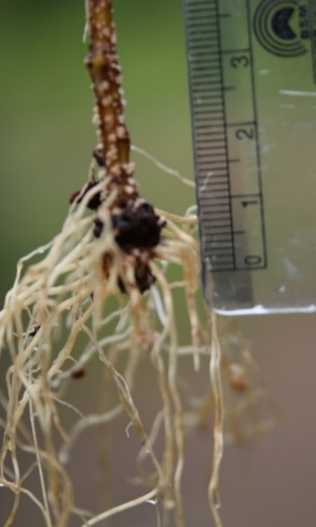  b | 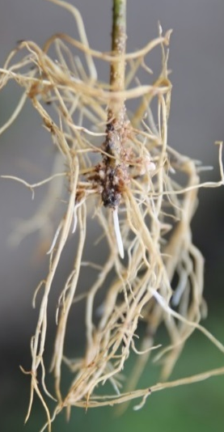  c
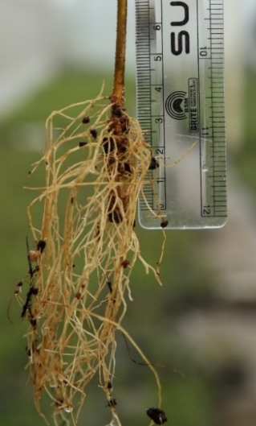  d | 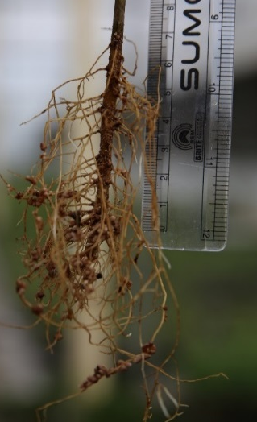  e | 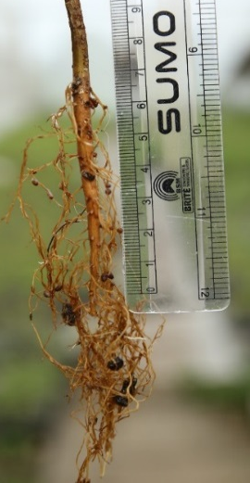  f
Figure. 1. Rooting pattern in Subabul clonal plants.
a. Group 1 (0.5-1.5 cm), b. Group 2 (1.6-2.5 cm), c. Group 3 (2.6-3.5 cm), d. Group 4 (3.6-4.5 cm), e. Group 5 (4.6-5.5 cm), f. Group 6 (>5.6 cm)

Table 2: Impact of IBA treatment on root traits of lateral cuttings (after 20 days in mist chamber and 10 days in hardening chamber, N = 2000)
 | Treatment | Root distribution | Root zone length (cm) | Proportion of roots (%) < 2.5 cm root zone | No. of roots | Rooting (%)
1 | IBA 5000 ppm | 4.9 a | 2.76 a | 57.1 | 21a | 88 a
2 | No hormone | 4.3 b | 1.97 b | 70.0 | 14 b | 81 b
 | Significance
 | Source | ** | ** |  | ** | **
** Significant at p < 0.01, Mean values of each trait with same letter do not vary significantly (p<0.05).

Table 3: Details of root traits in lateral shoot cuttings from different mother plant sources (after 20 days in mist chamber)
No. |  | Source |  | Mist chamber |  | Spacing (cm) | Cutting Diameter (mm) | Root distribution | Root zone (cm) |  | Shoot angle (Deg) |  | No. of roots |  | Rooting (%)
1 |  | MCPA |  | MC 1 |  | 20 x 15 | 2.58 a | 5.0 a | 3.11 b |  | 45 a |  | 22.0 bc |  | 87 a
 |  | MCPA |  | MC 2 |  | 20 x 15 | 2.58 a | 4.8 a | 1.67 c |  | 45 a |  | 15 de |  | 68 b
2 |  | OMCPA - Shade |  | MC 1 |  | 20 x 15 | 2.67 a | 5.0 a | 3.14 b |  | 48 a |  | 24 b |  | 82 a
3 |  | OMCPA - Open |  | MC 1 |  | 20 x 15 | 3.11 b | 3.6 b | 1.79 c |  | 35 b |  | 19 cd |  | 68 b
4 |  | HDCMA |  | MC 1 |  | 270 x 70 | 3.25 b | 3.4 b | 1.44 c |  | 35 b |  | 14 e |  | 43 c
5 |  | Seedlings |  |  |  |  | - | 5.0 a | 6.67 a |  | - |  | 46 a |  | -
 |  | Significance
 | Source |  |  |  |  |  | *** | *** |  | *** |  | *** |  | *** |  | ***
*** Significant at p < 0.001, Mean values of each trait with same letter do not vary significantly (p<0.05).

Figure 2: Rooting pattern of cuttings (MCPA) in two mist chambers (MC1 & MC2)

MC 1 had fine misting compared to MC 2. This resulted in difference in spray volume delivered to cuttings despite maintaining the same humidity with sensors. Excess (or low) misting can affect water stress in cuttings which impact root initiation. Delay in root primordia initiation will restrict the number of roots produced due to competition of emerging shoots from dormant buds. Basal accumulation of rooting hormone (auxin) in stem cuttings is maximum in the first 24 hrs of excision of cuttings after which it declines. It is important to ensure that right temperature and humidity conditions are provided in the first 24 hrs, during peak hormone accumulation in cuttings for early root initiation.

Impact of type of mother plant and shade on root traits

Basal diameter of lateral shoot cuttings (25-30 cm length) varies in different types of mother plants. Lateral cuttings from sand beds (MCPA and OMCPA) are at least 18% thinner than those from HDCMA (Table 2). Cuttings from mother plants raised in shade (MCPA and OMCPA) have 14% lower diameter than sand beds laid out in open (OMCPA without shade). Lateral shoots from sand beds in MCPA are more horizontally oriented by about 10 degrees’ higher angle than those in open sunlight (HDCMA and OMCPA without shade). Anatomical configuration and lignification of cuttings vary depending on the orientation of shoot from main stem.

Rooting is significantly higher in lateral cuttings from MCPA (87%) and OMCPA under shade (82%) than open sand beds (68%) and HDCMA (43%). Root distribution is also better in cuttings from covered sand beds than open sand beds and HDCMA (Table 2). Cuttings from MCPA and covered OMCPA have more roots (22-24) than OMCPA without shade and HDCMA (19 and 14 roots respectively). Root zone length is at least 73% higher in cuttings from MCPA (3.11 cm) and OMCPA with shade (3.14 cm), compared to open sand beds (1.79 cm), and HDCMA (1.44 cm). Seedlings have significantly higher number of roots (46) and longer root zone (6.7 cm) with good distribution (on par with MCPA cuttings).
Type of mother plant has a big impact on rooting pattern of propagules (Figures 3 & 4). Cuttings from MCPA and covered OMCPA have large proportion of plants (>70%) with more than 2.6 cm root zone. Majority of rooted cuttings from sand beds without shade (85%) and HDCMA (93%) have short root zone (less than 2.5 cm length). Open sand bed and HDCMA cuttings have generally large sclerenchyma bundles in the bark region compared to covered sand beds.

Figure 3: Rooting pattern of lateral cuttings in mother plants from MCPA, Sand beds (open & with shade) and HDCMA.

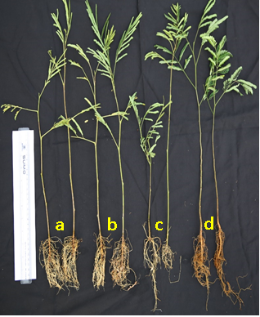

Figure 4: Root pattern in lateral cuttings from different mother plants and seedlings (a) MCPA (b) OMCPA - shade (c) HDCMA and (d) seedlings [Note the low root zone length in short cutting (c) from HDCMA]

Impact of insect infestation in mother plants

Control of psyllids in mother plants is essential for good rooting. Rooting rate can be low (<50%) when more than 30% mother plants are infested. Plant protection measures like periodic spraying of insecticides will keep infestation below 5% and ensure more than 80% rooting. The mother plants may be pruned to 15 cm height during September - October after the production season and maintained pest free until start of next season in November.

Standard Operating Procedure
Insect Management
Physical monitoring for insect infestation has to be done regularly by observing the mother plants using a sticky trap. When insect infestation is low (0-10%), rooting is not affected but when infestation level crosses 30% rooting is reduced significantly.
Control measure – Insecticides like Fipronil and Rogor should be sprayed to control psyllid attack. Application of neem based products (Neem oil, Neem soap) after an insecticide spray helps to keep infestation under control.
During peak infestation season Rogor and Fipronil spraying may be done twice a week. Adult insects can be trapped using sticky traps.

Mother plant maintenance and harvest of cuttings.
Mother plants in sand beds should be provided overhead shade to cut 50-75% light using agro-shade net.
1. Mother plants should be maintained at 15 cm height. Intensive pruning should be done in September, before commencement of production season to maintain juvenility of cuttings.
2. Vertically growing apical shoots should be removed periodically to obtain continuous production of lateral shoots. Dead and oversized branches should be pruned off once in three months.
3. Manual watering should be provided to mother plants one day prior to harvest of cuttings.
4. To reduce the time lag between harvest and loading of cuttings in mist chamber it is preferable to collect cuttings in two batches especially in summer months.
5. Cuttings may be collected and transported in covered water tubs or thermocol boxes to prevent desiccation and harvest shock due to loss of turgidity.

Management of Propagation system
Mist system should be managed to provide ideal temperature and humidity conditions in summer and winter seasons for root initiation and elongation. In summer months misting of 1 minute 30 seconds duration may be given at 20 minutes’ interval for first 12 days, from 9 am to 5.30 pm. For the next ten days, misting duration may be reduced to 1 minute based on manual observation of root development and moisture level of rooting media. When humidity falls below 85%, fogging should be done to maintain humidity. Fan and cooling pad have to be used, especially in summer months to ensure that temperature is maintained at 35º C. Plants may be shifted from mist chamber to hardening chamber after ascertaining root growth and maturity (when root colour becomes brown).

