
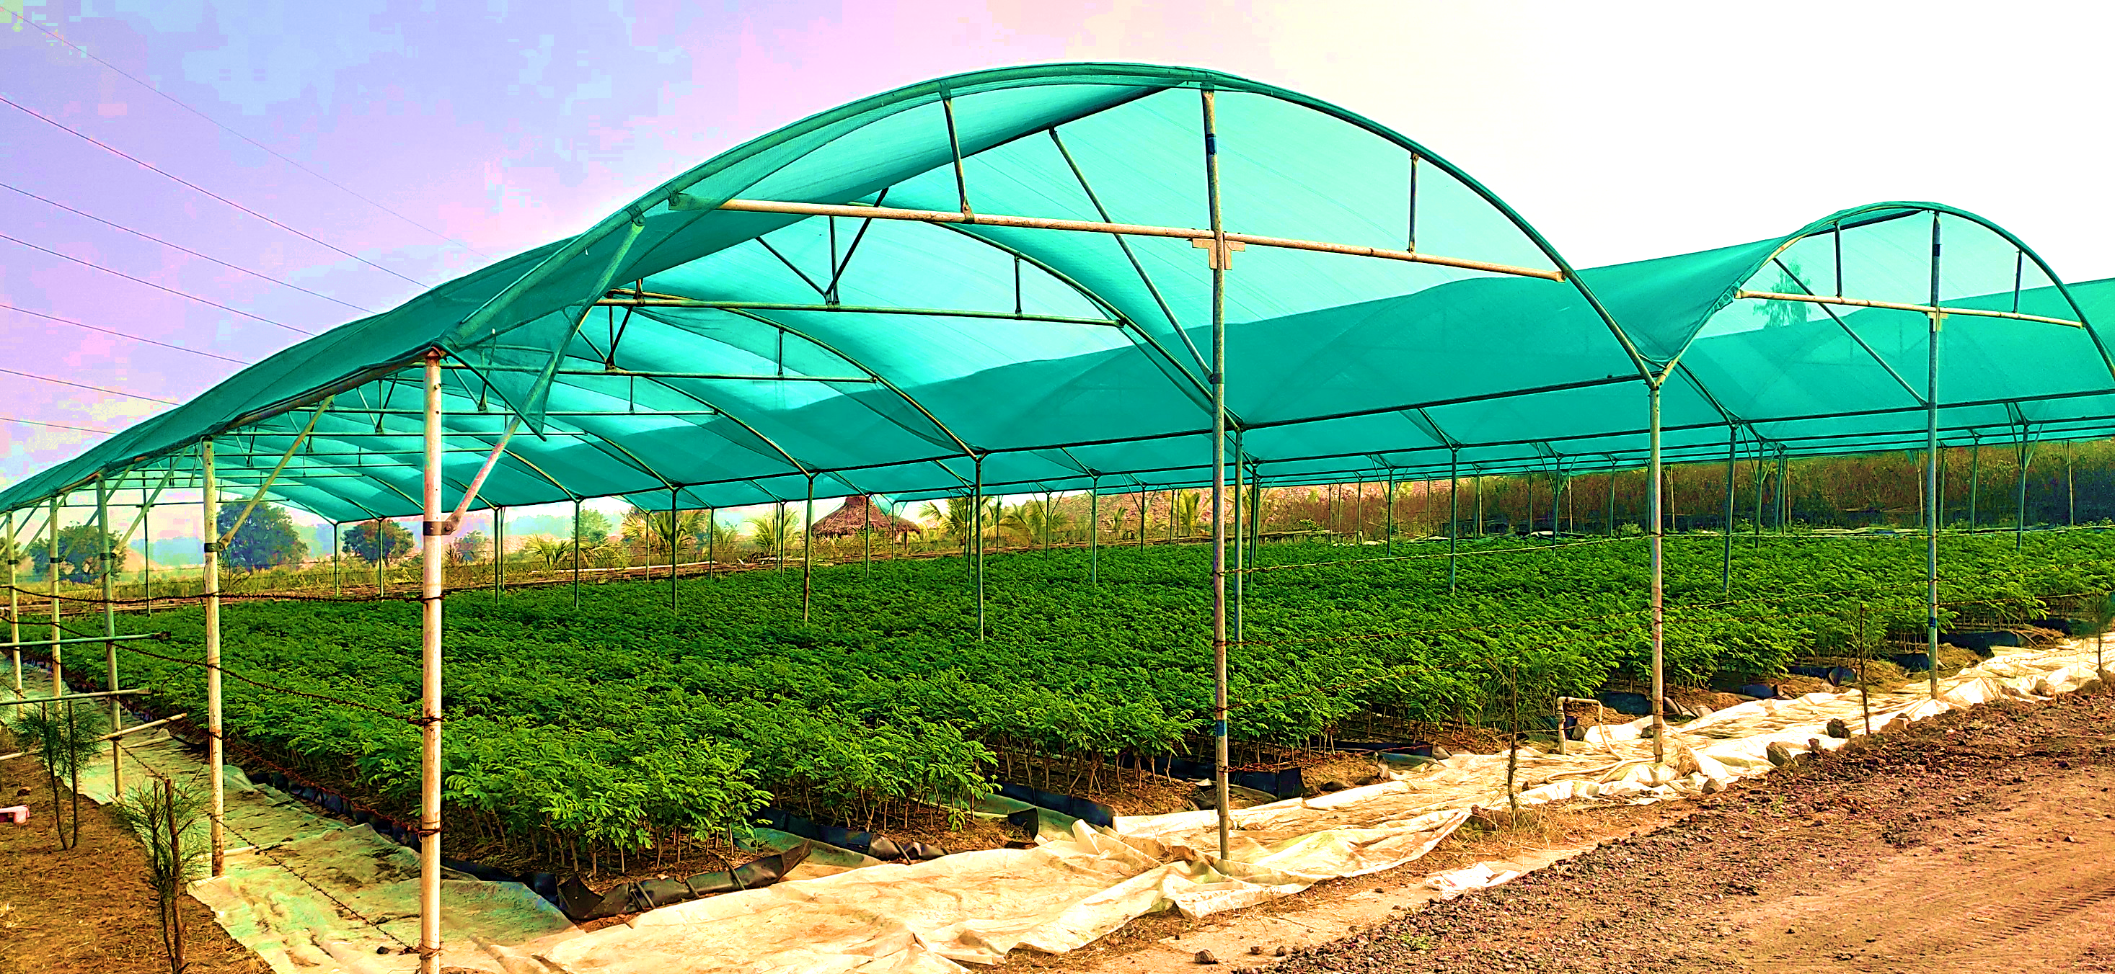
TRANSFER OF TECHNOLOGY - 2.0
SUBABUL CLONAL MULTIPLICATION
 LSTC – PSPD I TECHNOLOGY TRANSFER DOCUMENT I DECEMBER 2019

