ITC 1761 – “A Rocket Clone” for pulp wood industries

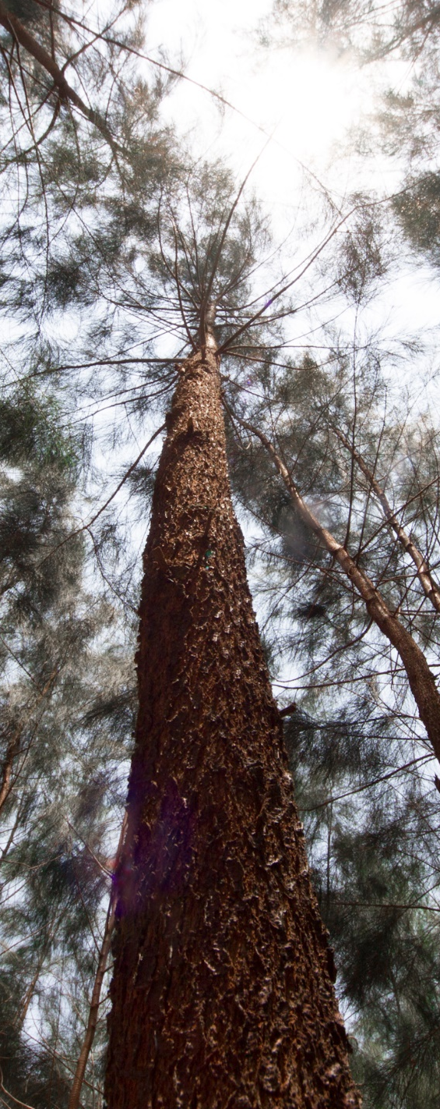
A new variety is developed by Life Science & Technology Centre, ITC Limited, named as ITC 1761, being named by farmers as “Rocket clone”.

ITC 1761 has a demonstrated wood yield potential of > 120 tons per hectare in four years, which is 30% higher than popular varieties in the country. The clone is a natural coppicer, has straight stem (Straightness value of 4); farm factor of 0.66; relatively tolerant to common pest and disease such as stem borer and blister bark and highly suitable for mechanical debarking with less than 5% wood loss. In addition, the clone is easy to multiply with the rooting efficiency of more than 95%, while all these properties make it a highly profitable clone for the farmers, besides its ability to enrich soil by nitrogen fixation.

From the industrial perspective as a pulp wood, ITC 1761 is a high density clone (0.65 g/cm³) with the Kraft pulp yield of 46-48% and fibre length of 0.99 mm (5% higher that local Casuarina varieties). Due to ease of debarking, ITC 1761 fully debarked in pulping process, which consumes 25-29% less alkali in comparison with direct Casuarina pulping with bark.

